NORFOLK PUNT CLASS 1960 - 1996.

By the early sixties, the Hard Chine design had met with general approval and a number had been built and more were in the planning stage. The first two hulls No 47 - Scoter and No 48 - Melanitta (built by Wyche & Coppock) and the third No 49 - Snark (built by Leslie Landamore), all featured open cockpits, which helped to keep the weight down, but tended to be terminal in the event of a capsize. To avoid this problem, built in buoyancy was introduced In No 50 - Flamer (built by Tom Harmer), and included in all subsequent hulls. The next four Nos 51- 54, were professionally built by Eastwood and Whelpton between 1961 and 1963. There then followed eleven more plywood hulls, all amateur built and all to Dick Wyche's Hard Chine design, the last of this series being No 68 - Ogo (Swordfish) built by J V de B Gray in New Zealand and I believe completed in 1978. No 63 - Bittern was also built in New Zealand, and together with No 68 is used in some quarters to justify the claim of the Punt Championships to World status! Altogether this came to nineteen hulls built in plywood to the Hard Chine design. As can be seen from the lists of Punt Championship and Gun Cup winners, this was a very successful design and eventually was adopted as a one design for all future Punts. The four Whelpton boats were all winners at different times, as were many of the others. No 56 - Puffin was lightly built by Tom Carter and sailed by his daughters Julia and Anne was almost uncatchable in light airs. No 57 - Avocet built and sailed by Justin Scott, was perhaps the ultimate shape. Although theoretically one design, the tolerances could be tweaked and Avocet had a particularly good planing hull, partly due to her shape aft and partly due to her lightweight construction, which was further enhanced when on sea trials off Brancaster in rough water, a number of her frames from forward of the mast came adrift. According to legend Justin threw them away. Despite this unconventional method of lightening the hull, Avocet survived and remains very competitive. Sadly, Puffin has not lasted quite as well.

At a Special meeting of Punt Owners held on 27th November 1976, it was a decided to accept GRP hulls built to the Hard Chine design into the Class and a subcommittee was set up to go into details. The sub-committee members, who later became the Trustees of the Fibreglass Norfolk Punt Fund (FNPF), were David Adler, Tom Harmer and Justin Scott. Colin McDougall was selected as the Builder and Derek Gibbs, the Punt Class Measurer, volunteered his immaculate home built Punt No 61 - Shoveller as a pattern for the mould. The first hull produced was seriously over weight at nearly 400 lbs and was a rejected by the FNPF. The second hull came out of the mould at 274 lbs, was accepted by the FNPF, and in due course became No 64 Golden Jubilee. The first hull was eventually sold off and became a slightly over engineered and heavy No 57 - Swallowtail. The initial weight problems encountered with the GRP Punts is not surprising - the Hard Chine design had been created specifically for building in plywood and as such had proved highly satisfactory. (No 47 - Scoter originally weighed in at the remarkable figure of 200 ibs). It was more difficult to construct the sharp angles and large flat panels of the Hard Chine design in GRP.

of 13 kts, which at the time was quite impressive. She has since been the subject of a drastic weight reduction programme by Matthew Thwaites and despite this, is still in existence under the name of Gargany. Two GRP hulls were built with plywood decks Nos 70 - Barnacle Goose in 1980 and No 72 - Dipper in 1981. Later GRP hulls became progressively lighter and more competitive but it was not until 1989 that a plastic Hard Chine hull No 75 - Rainbow Trout finally won the Punt Championships. Rainbow Trout had an extremely tall rig and although fast in light airs, was a bit of a handful in anything over force three. At the time of writing a total of ten GRP hulls have been built, the latest being No 81 - Grayling.

ln the early 1980s, the fortunes of the Punt Class were in serious decline, numbers of Punts on the starting line at Barton hardly justified Class races and no new Punts had been built since Dipper. At the November 1984 meeting of Punt Owners, concern was expressed for this situation, and it was decided to elect a Punt Class secretary, whose task among other things, was to liven up the Class. Slightly to my surprise, I was elected to the post.

At about this time two other developments appeared on the horizon, which were to have quite far reaching effects on the Class. The first was the extra trapeze (for the helmsman), and the second was the Double Chine design from Andrew Wolstenholme. I had been experimenting in 1984 with a second trapeze on Reed Bunting, mainly on Barton. Despite the fact that my second trapeze 'wire' was made of Kevlar, and tended to stretch when under load and I was not the most agile person on the planet, we had a lot of fun. It was clear that the extra power of the second trapeze would be very beneficial on open water, particularly to windward, and would go some way to counteracting our difficulty on handicap in strong winds. It was therefore decided at an Owners Meeting to allow the second trapeze for handicap races for a trial period of one year in the 85 season. After further testing on Barton in actual racing, it seemed to me that the helmsman was better off in the boat than on the trapeze. I was too tall, too heavy and not quick enough In the lulls and there was a tendency to sail slightly off the wind in order to support the helmsman on the trapeze. On Barton, the length of the course legs sailed were too short and the winds were too variable. Of course, more agile helmsmen would not necessarily encounter the same problems. In March 85, (again in Reed Bunting) we had the opportunity to try out the technique on the wide open spaces of Draycote Water and later in the year at Hickling Regatta (where my crew was Andrew Wolstenholme). I can't remember what his reaction was to double trapezing, but it wasn’t a complete disaster as we won the Martin Trophy. By the Punt Club Rules in force at the time, if the change to two trapezes was to become permanent, a two thirds majority of Punt Owners had to be In favour and the change also had to be passed by the Club Committee. This made for a certain amount of inflexibility and conservatism.
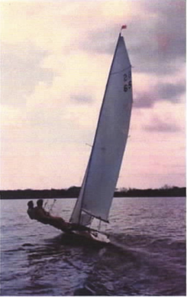
Reed Bunting - Hickling Regatta 1985.

The second factor that appeared around this time, the double chine hull, arose as a result of the desire by John Findlay, the Landlord of the Fisherman's Return in Winterton, to build a new fast boat to win the Three Rivers race. He had in mind a boat along the lines of a Punt, but being double chine, the hull would not conform to the existing Punt Class Rules. John was however, quite keen that his new boat should be allowed into the Punt Class. This then was the problem facing the Owners in early 1985. The designer was to be Andrew Wolstenholme and the builder was originally going to be Jack Chippendale. Part of the attraction to the Punt Class was that the design could be arranged so that the hull could be built using the stitch and tape method, and a kit could be made available. It was hoped that this method of construction might result in a revival in Punt building. The sailplan would conform to the existing Class Rules.At an owners meeting on 15th Feb 85, it was decided to form a sub-committee to observe the construction of the prototype and if the sub-committee liked what they saw, to recommend its acceptance into the Class. The sub-committee members were
Tom Harmer, Derek Gibbs, John Parker and me. Somewhere along the way. David (Fred) Saunders became the builder instead of Jack Chippendale. and construction commenced. John Findlay had decided to build the boat regardless of whether it would be accepted into the Punt Class, but happily the sub-committee were impressed with the construction and the looks of the hull. Although based on the Hard Chine design, maximum beam would be three inches greater and there would be two inches more freeboard at the bow. No 73, when she finally took to the water, looked like a Hardchine, and had much the same performance. She was well sailed, mainly by Fred Saunders, and won the 1986 Three Rivers Race, (on this occasion crewed by Mark Clarke and lan Jackson), but unfortunately didn't compete in the Championships. It wasn't until several years later when owned by James Hoseason and helmed by 'Hired Gun' Clive Robinson, did she manage to win the Championship, and that had more to do with her new mylar fully battened rig and ace helmsman than with her double chine hull. Putting her on the same handicap as the Morrisons seemed a bit tough, but I digress. The sub committee liked what they saw and although she was never measured ( she did not conform to the Hardchine Rules, so there was no point), a certificate was eventually issued. Unfortunately, the plan to produce a kit had run into a snag. It seemed that before the expense of producing a kit could be justified, it was necessary to have firm orders for several hulls. As there were no more orders in the pipeline. that was the end of that.

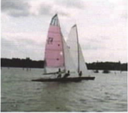
No 73 Razorbill and No 74 Blackbird, Barton.

While all these exciting developments were going on, there had been sporadic rumblings in some quarters about the difficulties of changing rules of the class because of the existing set up, i.e. two thirds majority and approval of the Punt Club Committee. This was understandably irksome to some of the Hickling Punt sailors, and I was inclined to agree with them. I was trying desperately to think up some new Class rules to encompass the Hardchine and Double Chine hulls, and getting
anything new approved under the existing framework was obviously going to be difficult. As a first step I set out to produce new rules for the conduct of Owners
Meetings.

A Punt Owners Meeting was scheduled for 21st February 1986 to approve (or not) the new rules for Owners Meetings and to sort out the construction rules to allow single and double chine hulls. Alter a great deal of discussion, a new set of rules 'The Rules and Procedures of the Norfolk Punt Owners Association' was approved by a majority of 13 votes to 1. Provision was made for Punt Owners who were not members of the Punt Club. Rules could be changed by simple majorities and the Punt Club Committee informed accordingly. If the Owner Members of the Punt Club Committee felt that the Rule change was undesirable in some way, they could call for
a Postal Vote of all Punt Owners. As the objectives of the Club and the Owners Association were the same and the people involved were more or less the same, no separate financial arrangements were envisaged. It was also at this Meeting that the Wolstenholme Double Chine design was approved and the issue of a certificate to No 73 was authorised. At some point during this discussion , it was suggested by Tom Harmer that we should consider reverting to the pre-war restricted class rules (updated where necessary to take account of modern construction materials and techniques). He has since told me that he didn't necessarily think it was a good idea. I wonder what he thinks now! A sub committee was appointed to draw up a new set of Class rules, consisting of Mike Evans, Tom Harmer, Simon Read, me and technical adviser Jack Chippendale, and we immediately set to and produced the new rules, an updated version of the pre-war restricted class rules. These rules were finally accepted at the Owners Meeting on 28th November 1986. All that was needed now was for someone to commission a design to these new rules.

While some Punt Owners were trying to sort out the Rules, others were busy with glue, tools and paint brushes. The Class, particularly the Traditional part of the fleet was undergoing a healthy revival. Simon Reed (Traditional Punt Representative) had been very active in encouraging the Owners of the Trad Punts to get back in action and it was working. Swallow II and Decoy did well in the 1986 Championship, corning first and fourth respectively, (both sporting, if that is the word, new cold moulded bottoms). Flight, Kipper, Didler, Shuck, Gamecock, Curlew and two Hickling boats - Rushlight and Limelight were afloat or promising to be afloat in the near future. Simon told me an amusing story about Martin, the last Traditional Punt built before the advent of the Hard Chines - apparently, due to her slightly odd shaped side decks, when a certain angle of heel was passed, rather than capsizing like a normal boat, the weight of the hull exceeded the buoyancy available and Martin would very gracefully sink sideways.

In 1987 I decided to personally fund a designer to draw plans to the new rules. I discussed the project widely and finally decided on Phil Morrison (recommended , I think, by Mike Evans). At this stage, I did not expect that I would be able to build to this design, because of the cost. I hoped that someone else who could afford to build, would like the design as much as I did. By a stroke of very good fortune, I suddenly and unexpectedly found myself in financial surplus and I lost no time in cornmissioning Simon Reed to build a plug and hull to the Morrison design. The new hull took shape in Simon's workshop at Hales Hall and from the start looked good. The hull had a triple skinned cold moulded bottom with ply sides and deck, and was very light and strong and breathtakingly beautiful. It seemed a pity to get it wet.
Blackbird No 74, the first Morrison, was our exhibit at Sailboat 89, and drew many admiring comments. Her first season racing was successful but not as successful as it might have been. The problem was the rig. I had substituted a Superspar mast for the usual Proctor F and it was not stiff enough. Allied with my old No 1 mainsail from Reedbunting which was very flat, the combination in windy conditions was not good. How the mast didn't break in that first season, I will never know. Despite rig and sail problems, Blackbird managed third place in the Championship that year.

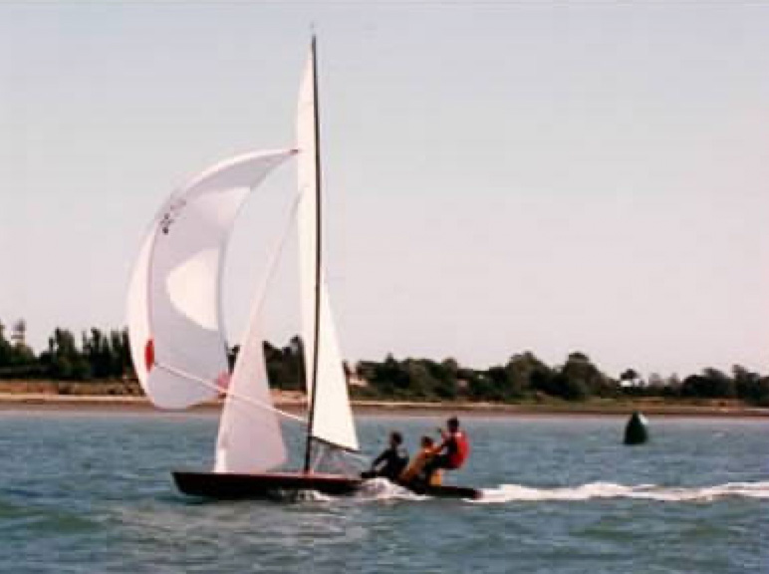

Blackbird - Chichester, note alarming mast bend.

During the following winter, we carried out rig improvements - two sets of spreaders gooseneck stays and jumpers. The result was a much stiffer mast, but it was not until the addition of a new Batt fully battened main that Blackbird started to perform. We won the prestigious Anchor Trophy in Chichester Harbour against a strong fleet including Laser 5000s, International Fourteens and 505s. In the 1990 Punt Championship we could only manage fourth. I can't remember what went wrong, it might have been wind speed. It soon became apparent that the Morrison hull was not much faster than the Hard Chine in light airs, but as soon as the wind picked up, it
was a different matter, - we flew. To the well known definition ‘A good Punt floats in a heavy dew’, could be added ‘and planes in a force 2’. Also, the Morrison hull handled much better in waves.
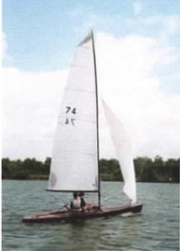

Blackbird with a stiffer mast and fully battened Batt mainsail.

Unfortunately in May 1991, I had a flying accident and suffered two fractured vertebrae in my back, which put me out of competitive sailing for several years. However, Blackbird had developed into a very fast boat, and my three sons happily took over, winning the Championship in 1991 and again in 1993. By this time I was beginning to recover and more was afoot to allow asymmetric spinnakers set from a retractable bowsprit. We rigged up a Laser top mast tied down to Blackbird's foredeck and hoisted a borrowed Int. Fourteen asymmetric, We blasted across Barton Broad at high speed and very quickly started to run out of sea room. Unfortunately, we had not incorporated a drop system in our temporary modifications. There was nothing else for it - the only way we could stop was to capsize, which we dld. We were, however, convinced that asymmetric was the way to go. By 1995, I had recovered sufficiently to have a go at the Championships again. The weather was kind (plenty of wind) and in a fleet of twenty six, crewed very efficiently by Mark 'Fastnet' Hingley, Blackbird won again.

At the 1995 Owners AGM, it was decided to allow asymmetric spinnakers for a trial period of one year, but not in the 1996 Championships.

I then migrated to Cornwall and resigned from the post of Class Sec. and eventually sold Blackbird to Chris Pilling. Chris continued Blackbird’s winning habit with another first in the Punt Championships. With more wins under subsequent management, I believe Blackbird has totalled five Championship wins and nine Progress Cup wins. Various other Morrisons - Peregrine, Shag, Saker and White Eagle, have also carried off the Championship Cup in the following years. The Morrison design had certainly proved itself. Other designs have been successful too, and the Hard Chine design in particular, has undergone somewhat of a renaissance with eleven new builds since the major rule change in 1986.

Since moving to Cornwall, I have visited Barton on two occasions to watch the racing. and I have been happy to see that the Class is still flourishing. Changing the Class from One Design back to its original Restricted Class rules seems to have worked. In my opinion, the diverse nature of the Class is one of it's attractions, and will ensure the survival of the Class for many years to come. I have seen a U tube video of an Optimist on foils, who I wonder, will be the first to try a Punt on foils?

Richard Sadler, Punt Class Secretary 1984 - 1995.

