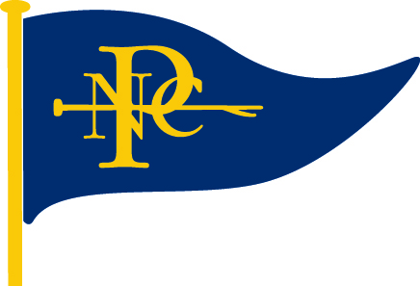
Norfolk Punt Club
Sailing Instructions
Revised March 2024

1. RULES
1.1 Racing will be governed by the rules as defined in the Racing Rules of Sailing (RRS).

2. NOTICES TO COMPETITORS
Notices to Competitors will be posted on the notice board located on the club pontoons.

3. CHANGES TO SAILING INSTRUCTIONS
Changes to Sailing Instructions will be posted on the official notice board at least 10 minutes before the warning signal of the race in which they take effect. The L flag should be flown.

4. HANDICAP RACES
4.1 All boats racing in handicap races shall sail to their Portsmouth Number and have their time corrected accordingly.
4.2 At its discretion, the committee may allocate a special Portsmouth Number to a boat, which the boat must sail to until further notice. All such numbers will be posted on the notice board.

5. ENTRIES
5.1 For Club races, an entry form for each race will be available on the club pontoon.
5.2 Any boat wishing to race shall enter or cause to be entered on this form before the preparatory signal of that race.
5.3 For Open events, all competitors shall submit entries in accordance with the notice of race.
5.4 River Cruisers are able to participate in handicap races on the discretion of the Race Officer.

6. SCHEDULE OF RACES
6.1 For Club races, the schedule of races is detailed in the club handbook and on the notice board. The OOD has discretion, with the agreement of sailors on the day, to combine starts for any series.
6.2 Starts must not be any earlier than those published in the handbook
6.3 For Open events, the schedule of races will be detailed in the notice of race.

7. CLASS FLAGS
Class Flags will be in accordance with the Norfolk and Suffolk Boating Association Handbook.

8. THE COURSE
8.1 The course to be sailed will be displayed on the club pontoon. In case of difference, the course displayed on the top level on the front of the Officer’s Box will take precedence.
8.2 A separate course for junior races may be displayed on the club pontoon below the main course, or indicated elsewhere at the race officer’s discretion.
8.3 The course display will consist of a series of coloured boards with white characters to be read from left to right. The colour of the board background (red or green) will indicate the side (port or starboard respectively) on which the buoy is to be left.
8.4 The number of rounds to be sailed will be indicated by a white figure on a black background at the end of the course display unless it is an average lap times race, where no rounds are displayed.
8.5 The race officer may, at his or her discretion, shorten course in accordance with RRS 32. ( A sound signal and a flag is displayed when the leading boat rounds the final mark of the course)
In this case the finish will be determined by when the leading boat next crosses the finish line in the process of sailing the prescribed course.
8.6 The course will not be changed after 5 minutes before the start. This changes RRS 33.
8.7 When mark 1 and mark A are consecutive ( in either direction) marks of the course, all boats shall pass to the east of Pleasure Island.

9. MARKS
9.1 Marks of the course will be pink / red buoys (except the Mark J which has a white buoy) displaying appropriate mark insignia as detailed below.
Mark D displays flag D
Mark J displays the J flag on a white buoy
Mark R displays the flag R.
9.2 Approximate positions of the marks are as follows:
Mark 1 – in the area of the broad north of the club pontoons
Mark 2 – near Pleasure Island and the East Gap
Mark A – in the south east corner of the broad, near the River Ant entrance
Mark N – in the south-west corner of the broad, near the Neatishead channel.
All other marks may be positioned anywhere on the broad. See map.
9.3 Starting distance marks will be red/pink buoys with white flags.
9.4 The exclusion zone marks are red/ pink buoys with a white flag with an X on the flag
9.5 The finishing mark will be a large yellow inflatable buoy.
9.6 Mark J will be used for junior races or may be used for other races if no juniors are racing.

10. AREAS THAT ARE OBSTRUCTIONS
10.1 A large inflatable red buoy, referred to as the Dolphin, placed in the vicinity of the northern shore at the entrance to Neatishead channel, denotes a shallow water area. It shall be treated as an obstruction and shall be passed to the east. RRS19 (Room to Pass an Obstruction) shall apply, excluding 19.2(a). RRS 18 (Mark Room) shall not apply.
10.2 The club pontoons shall be treated as a fixed obstruction and must always be passed to the east, the front of the pontoon.

11. THE START
11.1 Races will be started as follows:
Warning signal, 10 minutes before start, Class flag, 1 sound signal
Preparatory signal, 5 minutes before start, Flag P, 1 sound signal
A sound signal (a bell) will be given at 1 minute before the start, this changes RRS26.
Start, all flags removed, 1 sound signal.
This changes RRS26
11.2 The starting line will be a prolongation of an imaginary line drawn through the white signal post behind the officer’s box, and the red and white striped post in front of the officer’s box. Inner and outer distance marks may be used.
11.3 A starting exclusion zone may be marked by buoys displaying a flag marked ‘X’ positioned to leeward of the starting line. Boats may not sail between these buoys and the starting line before their preparatory signal.
11.4a Other than for boats described in SI 11.4b, If any part of a boat’s hull, crew or equipment is on the course side of the start line or its extensions during the minute before the start, they will not start until they have sailed completely to the pre-start side of the line around either distance mark. Flag I will not be flown. This changes RRS 30.1.
11.4b RRS 30.1 will still apply specifically to River Cruisers taking part in NPC Open Events or Regattas.
11.5 If any boat has failed to comply with SI 11.4a or b, as appropriate, at the start, one extra sound signal will given, the class flag will remain flying at the dip until all boats have so complied. This changes RRS 29.2.
12. COMMITTEE BOAT /PONTOON STARTS
12.1 If races are to be started from a committee boat / pontoon, a yellow flag will be flown on the club pontoons.
12.2 The starting line will be between a signal post on the committee boat / pontoon, and an outer distance mark. The line will be limited by an inner distance mark.
12.3 A board representing naval numeral flag 8 will be displayed to the left of the first mark to be rounded following the start. The committee boat may display the course, but SI 8.1 is not changed.
12.4 The inclusion of the letter F, in white on a blue background, in the course indicates a clubhouse finish, having rounded the mark preceding the letter F the prescribed number of times.

13. THE FINISH
13.1 The finish line will be an imaginary line drawn from the central position of the signal mast in front of the officer’s box to, but not beyond, a yellow inflatable buoy.
13.2 After finishing, a boat is still racing until her hull, crew and all equipment, in their normal positions, have crossed the finish line.

14. PROTESTS AND REQUESTS FOR REDRESS
14.1 Protest forms are available from the officer’s box. Protests shall be delivered in writing to the officer’s box, accompanied by a fee of £1, within the protest time limit.
14.2 For the purposes of RRS 61.3, the protest time limit will be 60 minutes after the finish of the last boat in that race, except where the race is in the last series of the day, in which case the protest time limit will be 30 minutes.

15. SCORING FOR CLUB RACES
15.1 Day members and members of affiliated clubs will not be scored. Club members will be scored according to their finishing positions including day members and members of affiliated clubs.
15.2 Series scoring will be in accordance with the Club Rules and Trophies handbook.

16. SCORING FOR OPEN EVENTS
16.1 Sail-overs will not be scored
16.2 If three or fewer races are available, a boat’s score shall be the total of all her race scores. This changes RRS A2.

17. SAFETY REGULATIONS
17.1 Personal flotation devices shall be worn by all DINGHY sailors, at all times, while afloat. This changes RRS 40
17.2 When a red flag is displayed on the club pontoon, all competitors, in all competing boats, shall wear personal flotation devices. This changes RRS 40.
17.3 Any competing boat whose crew fails to comply with 17.1, or 17.2 when applicable, will be immediately disqualified from the current race.
17.4 Boats that retire from a race shall notify the race officer as soon as possible.

18. PRIZES
Prizes will be awarded in accordance with the Club Rules and Trophies handbook.

19. DISCLAIMER OF LIABILITY
The club will not accept liability for material damage or personal injury or death sustained in conjunction with, prior to, during, or after racing. Attention is drawn to RRS 1.2 and 4.
19.1 The responsibility for a boat’s decision to participate in a race or to continue racing is hers alone.

20. INSURANCE
Each participating boat shall have valid third-party insurance for a minimum of £2,000,000.

21. ALTERNATIVE PENALTIES FOR RIVER CRUISER CLASS YACHTS

21.1 For River Cruiser Class yachts, the 1 turn and 2 turns Penalties (rule 44.1) are replaced by Time Penalties, of 1 and 2 minutes respectively added to the Yacht’s elapsed time, to be acknowledged by the said yacht flying a green rectangular flag.
21.2 It is the responsibility of the helm to declare to the Race Officer, within the prescribed time limit for protests, which penalty or penalties the yacht is taking.
21.3 A yacht that fails to make a declaration will be assumed to have retired.
21.4 It is the responsibility of other competitors to ensure that these provisions are enforced.
21.5 This amendment applies for all races, including allcomers.

Barton Broad
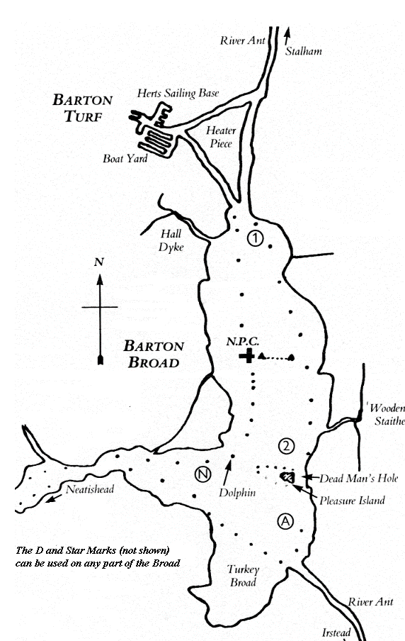
(Not to scale)

The D, R and J marks (not shown) may be laid in any part of the Broad.
The Dolphin denotes an obstruction and shall be passed to the east (see SI 10.1). Mark Room does not apply.

Revised April 2022 and valid until further notice.

