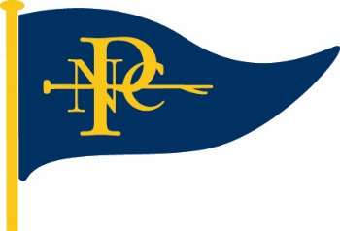
Norfolk Punt Club
2024 Open Event Entry
ENTRY FEES
Barton Bunny: £10 per boat; £15 for double handers; tea and cake available at normal NPC prices
Cruiser Open: £15; tea and cake available at normal NPC prices
YBOD Open: £15; tea and cake available at normal NPC prices
Punt Open: £15; tea and cake available at normal NPC prices
Punt Champs: £15; tea and cake available at normal NPC prices
Athene Cup: £10, including tea and cake for competitors

NOTES AND CONDITIONS OF ENTRY
Entrants are reminded of NPC rule 27 – “All boats sailing at the NPC shall have third party insurance for a minimum of £2,000,000”. The club accepts no liability. Parents are responsible for their children at all times and the Club takes no responsibility.
I agree to be bound by the rules of the Norfolk Punt Club and undertake to sail in compliance with the RYA racing charter. I confirm that I am in possession of a current measurement certificate, insurance and Broads Authority licence for the yacht mentioned below.
All visiting competitors will be deemed temporary members of the Norfolk Punt Club during the event and as such shall abide by the club’s rules.

I agree the this form and data will be retained for 1 year by the NPC if I win a trophy.
Signature of Helm: Date:
This entry form is for the boat and helmsman combination shown below.
BLOCK CAPITALS PLEASE:
Sail no | Boat name | Helmsman | Handicap | Crew
Cruiser / Y & B / Bittern / Punt (Circle as appropriate)
For Barton Bunny only: Class of Boat …………………………………………………………………………….

Email address:
Phone number:

